HILLSIDE 5 BRUNSWICK TERRACE WEDNESBURY WEST MIDLANDS WS10 9DA

0121 502 4268 hgamble@ropetask.com direct: 07970 054579

Project/Contract
Site Contact
Site Address
Project Start Date
Expected Duration
Projected Completion Date

 | Name | Title | Signature | Date
Document Author | Haydn Gamble | Director | 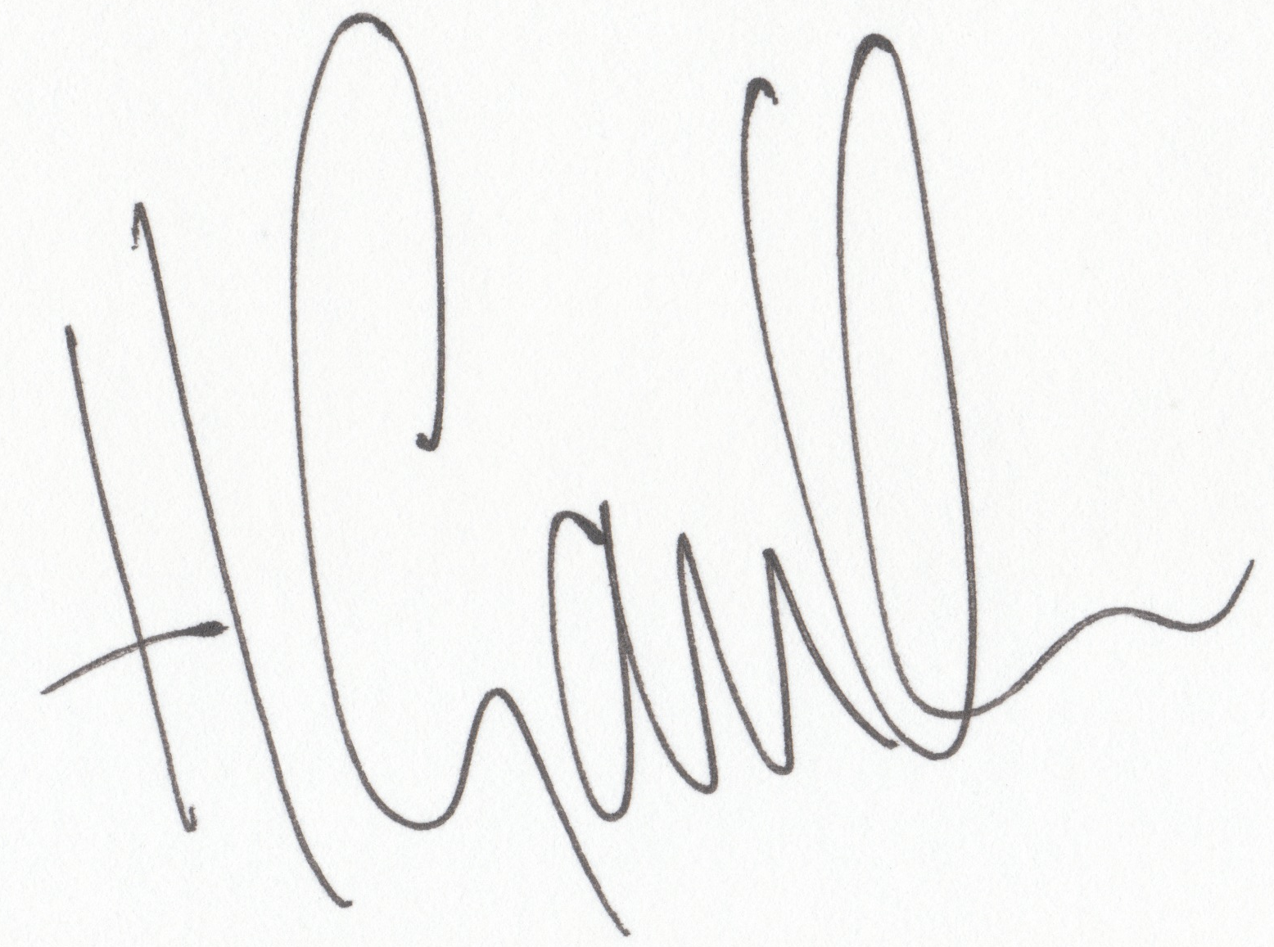
Authorised by
Authorised by
Authorised by (for Client)

Rope Task Contact Details
 | Director | Site supervisor
Contact  Tel  Mobile | Haydn Gamble  07970 054579 | Haydn Gamble

Work Task Description:

See additional drawings and technical data sheets when supplied by client – these will be attached at the end of this Safety Method Statement

Monitoring and revision of method statement:

Haydn Gamble will monitor this safety method statement while the job is progressing, improvements will be made if required and added at the back of this document.

Quality Control:

Haydn Gamble to monitor quality of the work

Tools to be used: (this section completed on site if required)

Tool | Trained in Use ? | Condition of Tool | Pre-use check (on site)

Site storage

Site Working Times

Number of staff

Two members of staff at all times when rope access and industrial climbing techniques are employed. Both must be trained in rescue with one operative minimum trained to IRATA level 3 rope access supervisor level.

Staff & Training

All staff must be IRATA rope access trained and hold a current training certificate. An IRATA level 3 rope access supervisor will be on site at all times to supervise the rope access works.

Site Supervisor

Haydn Gamble – IRATA level 3 – Competent inspector of fall protection equipment – NEBOSH trained – HSE approved First Aider

Induction / Tool Box Talk

Discussion of the work task and rope access setup will be given at the start of each day.

Fire Evacuation procedures – (Client to provide specific details and/or briefing)

Rescue Procedures

Level 3 rope access supervisor will be on site at all times and is highly trained in rigging for rescue and technical rope rescue procedures.

Additional information regarding the use of the Petzl ID for rope rescue:

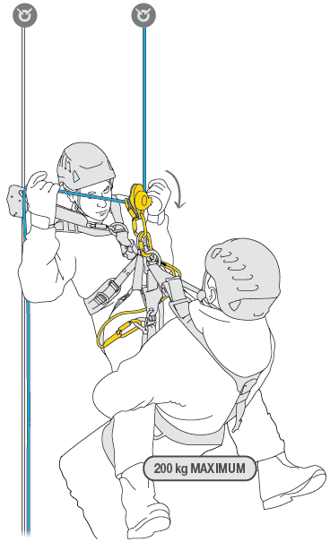

Maximum 200kg load for the Petzl ID, rigging for rescue essential for workers over 100kg, take into account the weight of tools and equipment being carried by the operative also.

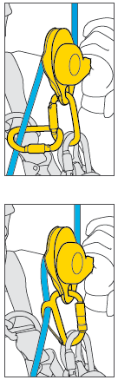

A breaking “extra friction” karabiner must be employed

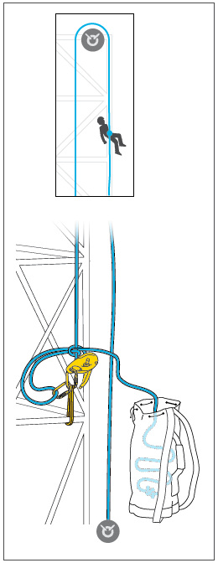

Releasable anchors – Rigging for rescue before work commences

Accidents and/or near miss investigation

In the event of accidents or near misses Haydn Gamble will use the pre-planned investigation process to protect all evidence of what has happened and report back to the client.

Anchor Points

The maximum impact load on the user in the event of a fall should not exceed 6kN, therefore, as a general rule, the static strength of anchors, with the exception of some deviation anchors, should be at least 15kN.

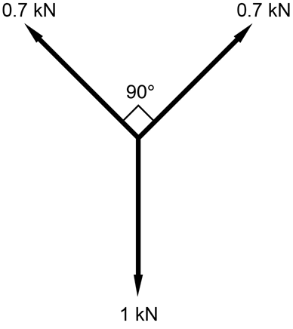

Maximum rigging angle for rope access anchor points, with exception of tensioned lines.

Edge Protection

Technicians should always ensure precautions are taken to prevent damage to anchor lines when they are in use. Hazards such as sharp edges, abrasive surfaces, corrosive substances and heat sources are common in the workplace and may damage ropes which may come into contact with them or close proximity. Wherever possible, any hazard that could cause damage to the anchor lines should be removed. Technicians should utilise the hierarchical approach when identifying rope protection and edge management methodology, which prioritises the removal of hazards before considering avoidance through rigging methods or mitigation through rope protection. The following IRATA edge management poster illustrates that hierarchical approach, and is an excellent reference tool for technicians when considering rope protection and edge management methods. In addition to this poster, technicians should refer to ICOP Part 2, 2.7.10 and ICOP Annex P for further guidance.

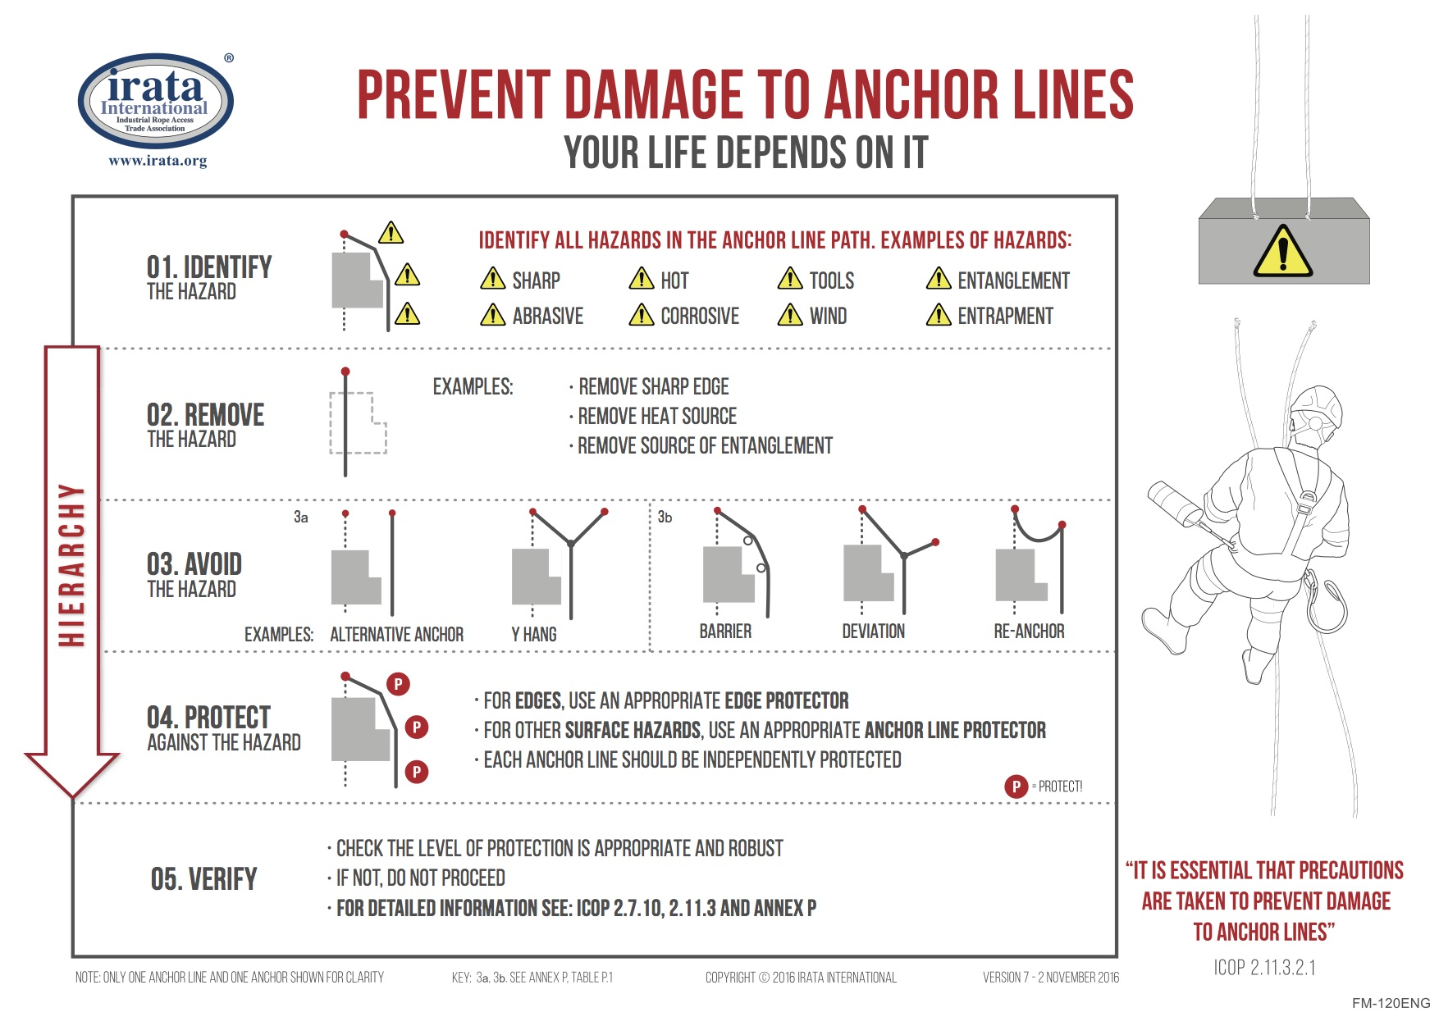

Hierarchy of rope protection to be followed from IRATA ICOP

Environmental Conditions

Work will be stopped at the discretion of the site supervisor if weather conditions pose a threat to the safety of the work team. This can be wind speed, heavy rain, ice, snow and thunderstorms.

Permits to work

As required by site/client.

Manual Handling (completed on site for all equipment over 20kg)

Equipment | Weight of Equipment | Precaution for lifting

Welfare and first aid

Welfare facilities are to be provided by client, Rope Task will provide HSE approved first aider and first aid equipment.

Exclusion Zones (at anchor points and below working area)

Roof access locked to secure anchor area

Chapter 8 Pedestrian Barriers used as exclusion zone below working area

All equipment is to be attached to the operatives harness using appropriate lanyards

Equipment Inspection

Under LOLER Regulations all rope access equipment must be thoroughly inspected by a competent person at intervals no greater than six months. Haydn Gamble is the Rope Task competent person for this inspection and detailed records are kept.

Daily pre-use inspection of all equipment by each operative, buddy checks also carried out on each others equipment before work starts.

Pre-use check register of rope access equipment, this includes operatives harness, ropes, rigging, ascenders, descender and all other associated equipment.

Name | Pre-use ckecked completed | Sign & Date

Communications

At all times working adjacent to each other and in verbal communication. If out of range for verbal communication then site radio’s will be used.

Safe System of Work

  - Tool box talk by supervisor on the days work task and arrangements

  - Site supervisor will ensure site is safe to commence work, check on environmental conditions, no dangers from other works or site conditions. Permits issued and controls in place if required by client.

  - Exclusion zones established at anchor point area (if required) and below working area where required. (see figure 10 page 67 ICOP)

  - Staff will transport rope access equipment, rescue equipment, tools and materials to roof storage area. All manual-handling activities will have been assessed at this point.

  - All operatives will daily inspect their own rope access equipment and don harnesses, helmets etc. Daily pre-use check will be completed and signed off.

  - Site supervisor to check that all tools have lanyards attached and are secured to operatives harness.

  - Site supervisor will monitor the rigging of ropes and choice of anchor points. All working and safety ropes are to be attached to separate anchor points . All operatives are to use a double rope system consisting of working rope and safety back-up rope at all times while working.

  - Site supervisor will now approve the use of the appropriate edge protection. Hierarchy of rope protection to be followed from IRATA ICOP

  - Operatives will approach the area of ascent or descent with additional fall protection restraint line or safety rope when required. Supervisor to monitor this and establish this extra system when required.

  - Operatives to attach safety backup device and ascender/descender to the ropes. All operatives are to use a double rope system consisting of working rope and safety back-up rope at all times while working.

  - Function test of equipment will now take place.

  - Technicians will descend/ascend to work position and perform task. See page 2 “Work Task Discription.”

  - At the end of each working day, all rope access kit must to be returned to the Rope Task office or stored securely on site. No equipment to be left out on any roofs without the permission of the site supervisor.

Method statement induction records

I confirm that I have been inducted in the above method of works and will work in accordance with the instructions given in this method statement.

Name | Date | IRATA Number | Sign

PPE Issue

PPE Item | Name | Sign | Date

Insurance Details:


